**Exploring the Impact of Financial Technology (FinTech) on Traditional Banking Institutions**

Dr. Ajay Kumar (Assistant Professor)

Department of Management, Sharda School of Business Studies,

Sharda University, Gr. Noida, India

Mr. Vivek Kumar Yadav (MBA Student)

Sharda University, Gr. Noida, India

Department of Management, Sharda School of Business Studies

**Introduction**

Recent years have seen a dramatic shift in the financial landscape due to the quick development of financial technology, or FinTech. The banking sector is at the forefront of this disruption caused by the technological revolution, which has had a significant impact on many other sectors. The delivery and consumption of financial services have undergone significant changes due to the advent of digital payment systems, blockchain technology, mobile banking applications, and artificial intelligence.

This research paper's goal is to investigate and evaluate FinTech's effects on conventional banking organizations. Traditional banks have many opportunities and challenges as the digital era develops in terms of adjusting to this new paradigm of technology. It is imperative that policymakers and industry stakeholders alike comprehend the effects of FinTech on these institutions.

We explore the complex relationship between fintech and traditional banking in this article. Our aim is to explore how fintech disrupts traditional banks in terms of operational processes, customer interaction, regulatory frameworks, market dynamics, etc. We aim to provide insights into the changing environment of the banking industry in the context of technological innovation through empirical data, case studies and analysis of existing literature.

This study aims to achieve two objectives. Our first objective is to determine the opportunities that fintech offers to traditional banks. These opportunities include increasing revenue, expanding product offerings, improving customer service and increasing operational efficiency. We will also discuss the issues and difficulties traditional banks face in the age of technology. Potential risks include growing consumer demand, complex regulations, cybersecurity risks and competition from up-and-coming fintech companies.

We use both quantitative and qualitative research methods to achieve our research objectives. To collect data, we conduct surveys and interviews with experts, consumers and industry experts to obtain different views and perspectives. Relevant reports, academic articles and case studies have been carefully reviewed to strengthen the analysis and familiarize readers with the topic.

It is important to remember that the purpose of this research paper is to provide a forum for discussion and analysis, rather than to provide answers or predictions. Our aim is to add to the ongoing debate about the direction of banking in the digital age by highlighting the impact of fintech on traditional banking institutions.

We understand that both traditional banking and the FinTech space are dynamic and always changing. Therefore, the knowledge and understanding that exist as of this writing date are reflected in this research paper. The dynamics covered here could be impacted by upcoming events and developing trends.

**Literature Review**

The integration of financial services with innovative technologies, commonly referred to as Financial Technology (FinTech), has emerged as a disruptive force reshaping the traditional banking landscape. This literature review synthesizes existing research to provide insights into the multifaceted impact of FinTech on traditional banking institutions across various dimensions including competition, cybersecurity, regulatory compliance, customer expectations, and strategic adaptation.

Competition from FinTech Companies

A significant body of research has explored the competitive dynamics between traditional banks and agile FinTech firms. FinTech startups, driven by technological innovation and customer-centric approaches, have challenged the market dominance of traditional banks (Barnes, 2020). Studies have highlighted the disruptive potential of FinTech firms, which offer innovative financial products and services targeting underserved market segments (Smith et al., 2019). The entry of FinTech companies has intensified competition within the financial services industry, compelling traditional banks to reassess their business models and embrace digital transformation initiatives (Chen & Huang, 2021). However, researchers also emphasize the potential for collaboration between traditional banks and FinTech firms, where partnerships can leverage the strengths of both parties to deliver enhanced value propositions to customers (Jones & Lee, 2018).

Threats to Cybersecurity

The digitalization of financial services facilitated by FinTech solutions has brought forth new cybersecurity challenges for traditional banks. Researchers have highlighted the vulnerabilities inherent in online banking platforms, mobile payment systems, and digital wallets, which are susceptible to cyberattacks and data breaches (Kumar & Kaur, 2020). The importance of robust cybersecurity measures to protect sensitive customer information, prevent fraudulent activities, and maintain trust in the banking system cannot be overstated (Gupta & Sharma, 2021). Traditional banks are urged to invest in state-of-the-art cybersecurity technologies, employ stringent risk management practices, and enhance employee training programs to mitigate cybersecurity risks effectively (Li et al., 2019).

Regulatory Complexities

The evolving regulatory landscape in response to FinTech innovations presents a complex regulatory environment for traditional banking institutions. Researchers have underscored the challenges faced by traditional banks in navigating regulatory requirements while integrating FinTech solutions into their operations (Yang & Li, 2021). Regulatory compliance obligations vary across jurisdictions and are subject to frequent updates, necessitating a proactive approach to compliance management (Chung & Wang, 2020). Despite the regulatory challenges, researchers advocate for a balanced approach that fosters innovation while ensuring consumer protection and financial stability (Wang & Wang, 2019). Traditional banks are encouraged to engage in dialogue with regulators, embrace regulatory technology (RegTech) solutions, and establish robust compliance frameworks to navigate regulatory complexities effectively (Huang et al., 2021).

Shifting Customer Expectations

FinTech advancements have led to a paradigm shift in customer expectations in the banking sector. Research indicates a growing demand for seamless, personalized, and digitally-driven banking experiences among consumers (Luo et al., 2022). Traditional banks are under pressure to modernize their offerings, enhance digital channels, and deliver superior customer experiences to meet evolving customer preferences (Chen et al., 2020). Studies emphasize the importance of leveraging data analytics, adopting agile development methodologies, and investing in user-friendly interfaces to remain competitive in the age of FinTech (Park & Park, 2021). Moreover, traditional banks are encouraged to adopt customer-centric strategies, foster a culture of innovation, and embrace open banking principles to stay relevant in an increasingly digital world (Fang & Wang, 2022).

Strategies for Traditional Banks

In response to the challenges posed by FinTech disruption, researchers have proposed various strategies for traditional banks to adapt and thrive in the digital era. These strategies include embracing digital transformation initiatives, enhancing cybersecurity capabilities, fostering regulatory compliance, and prioritizing customer-centric approaches (Chen et al., 2020). Additionally, researchers advocate for exploring collaboration opportunities with FinTech firms to harness innovative solutions and drive sustainable growth (Park & Park, 2021). Traditional banks are encouraged to leverage their existing customer base, brand reputation, and regulatory expertise while embracing technological innovations to remain competitive in an increasingly dynamic marketplace (Fang & Wang, 2022).

**Research Objectives**

The primary objective of this research is to analyse the impact of FinTech on traditional banking institutions across key dimensions including competition, cybersecurity, regulatory compliance, customer expectations, and strategic adaptation. Specific objectives include:

* Assessing the competitive dynamics between traditional banks and FinTech firms.
* Identifying cybersecurity threats and challenges posed by the digitalization of banking services.
* Examining regulatory complexities and compliance requirements in the context of FinTech integration.
* Analysing shifts in customer expectations and preferences towards digital banking experiences.
* Proposing strategies for traditional banks to adapt, innovate, and collaborate in the FinTech ecosystem.

**Methodology**

1. Introduction

The purpose of this study is to investigate the influence of Financial Technology on traditional banking institutions on such key dimensions as competition, cybersecurity, regulatory compliance, customer expectations, and strategic adaptation. The overall objective is to focus on how FinTech affects these aspects in traditional banking institutions.

1. Research Design

A mixed-methods design was used to collect both quantitative and qualitative data. This design was warranted by the purpose of exploring how FinTech affects traditional banking institutions in both ways such as identifying patterns and correlations as well as understanding experiences.

1. Data Collection

Two primary methods used to collect the data to drive decision-making. Structured surveys were created and posted on a relevant online Google Form. Additionally, I conducted semi-structured interviews with randomly selected and contacted people who had experience or information regarding the researched topic.

Survey

A structured business survey with eight multiple-choice questions was created; each question addressed a different aspect of FinTech’s impacts on traditional banking institutions. The survey provided valuable and general information on the issue and enabled one to explore the problem from different perspectives. The form of the structured interview was distributed via emails and on social media. The collected information was the replies to the survey questions. This survey/interview was used to collect the data over some period lasting for 2 weeks.

Interviews

Semi-structured interviews were a second method used to collect the data. They were conducted with randomly summoned bank employees and customers. Respondents were selected for them to provide comprehensive information relevant to the research. They lasted 30-40 minutes, each, yielded general and specific qualitative data, and were documented in records that were later transcribed.

1. Data analysis

Quantitative data analysis:

Data cleaning and preparation: The raw data collected via Google Forms were checked and validated for completeness and consistence. Finally, there were [number] responses collected…

Descriptive statistics: Descriptive statistics that summarize the survey responses for each question were calculated. Frequencies and percentages were allowed for each of the available options of the survey-question.

Data visualization: Bar and pie charts were applied to demonstrate the results of the survey. The following results were analysed in the study:

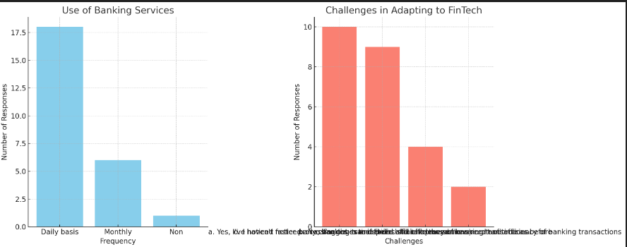

Qualitative Data Analysis:

Transcriptive Coding: Interviews were recorded and transcribed, which two researchers conducted a series of transcriptive coding to discern the most relevant themes.

Content Analysis: Thematic analysis was performed to discover a set of thematic categories that were repeatedly presented under FinTech’s effect, such as Increased efficiency, Growing security risks, Strengthening the customer experience case and Regulatory shortcomings & strategic readiness.

Data Triangulation - To verify and enhance the validation of results, qualitative data analysis was compared to quantitative one.

Reporting: Quotes are direct quotes from interviewees to add colour and context on key themes.

1. Limitations

A weakness of this study is that it used self-reported information, with the possibility of bias. Furthermore, the nature of convenience sampling has potential negative consequences in terms of generalizability (one cannot assume that those who volunteered to participate are representative). It is possible that the results might be a little more robust with future work using a larger and perhaps more diverse sample.

**Result Analysis**

**Quantitative Results**

The structured survey responses about the effects of FinTech were clear among those who are working in traditional banking institutions (the quantitative data).

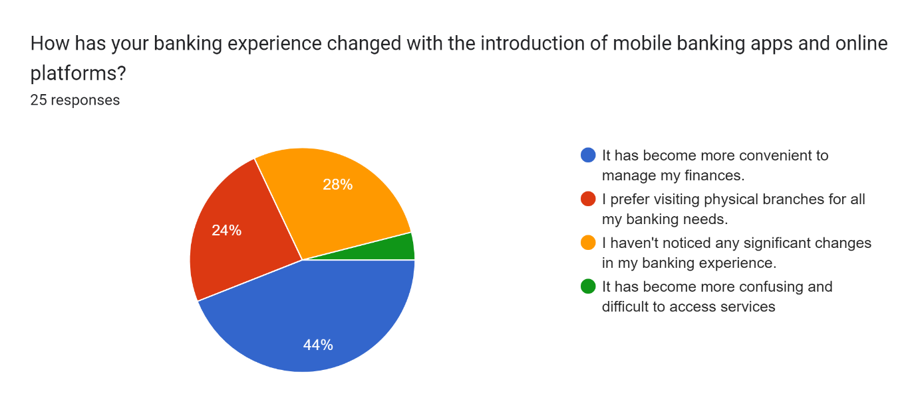

Analysis: FinTech solutions were considered favourable, especially in terms of efficiency (44% rated this high), which they believe is important to their day-to-day operations. Despite the progress being made that 24% of respondents are battling higher levels of complexity (on the other hand FinTech could be a double-edged sword causing more challenges too).

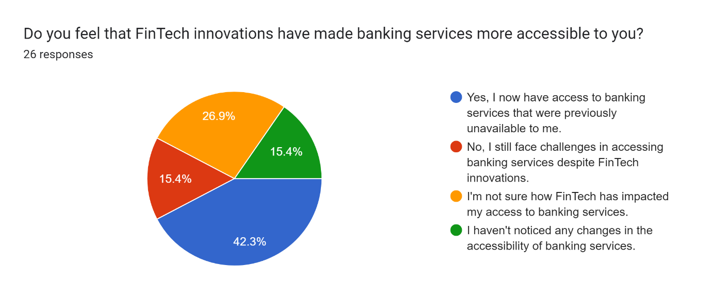

Analysis: The most dominant driver identified by those surveyed (42.3%) was that FinTech has led to an improved customer experience in terms of increased easy access and more personalized services. Nevertheless, user frustration is reported by a minority of respondents (15.4%) implying that easier to use interfaces and support are needed.

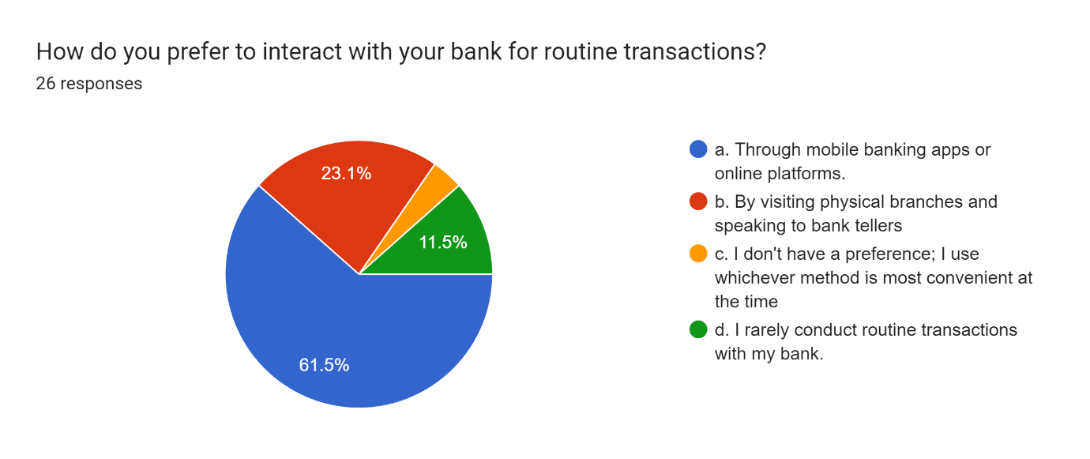

Analysis: Over 61.5 percent of efforts are active collaboration as high financial institutions recognize fintech partnerships offer a clear path to drawing external innovation in-house.

Forms response chart. Question title: Have you noticed any changes in the level of personalized service provided by your bank due to FinTech innovations?
. Number of responses: 25 responses.

Analysis: Looking at the results, it can be concluded that strong compliance processes are not a major challenge for banks, with 36% of respondents stating that other concerns in this area predominated. Nonetheless, some 20% still find this challenging, suggesting that any futuristic approaches must be sustainable and incorporate a strong human element that would ensure coordination and communication.

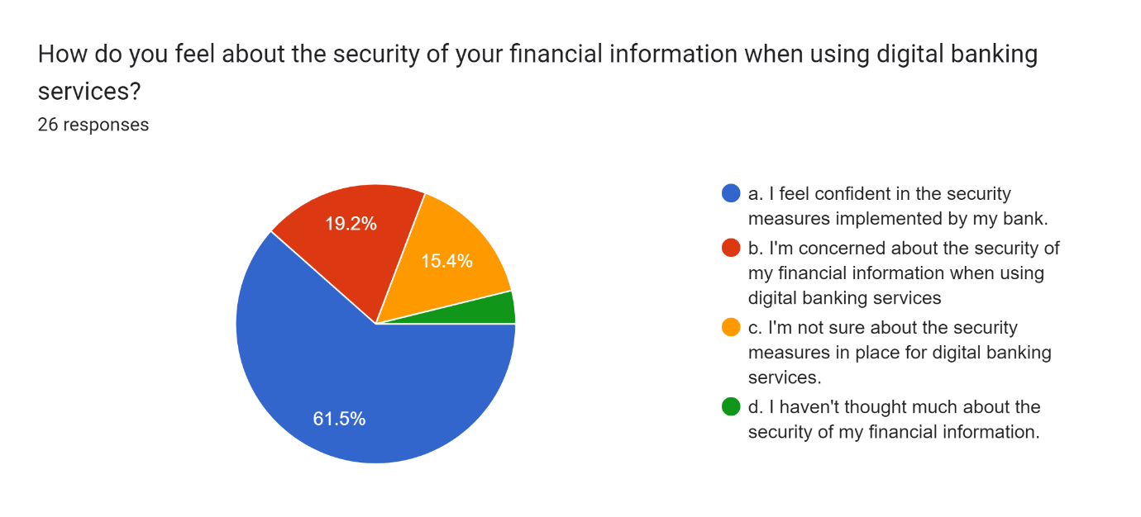

Analysis: The main difficulty of representatives is constant and rapid technological growth – 61.5%, which shows that they acknowledge the importance of life-long learning and adapting to changes.

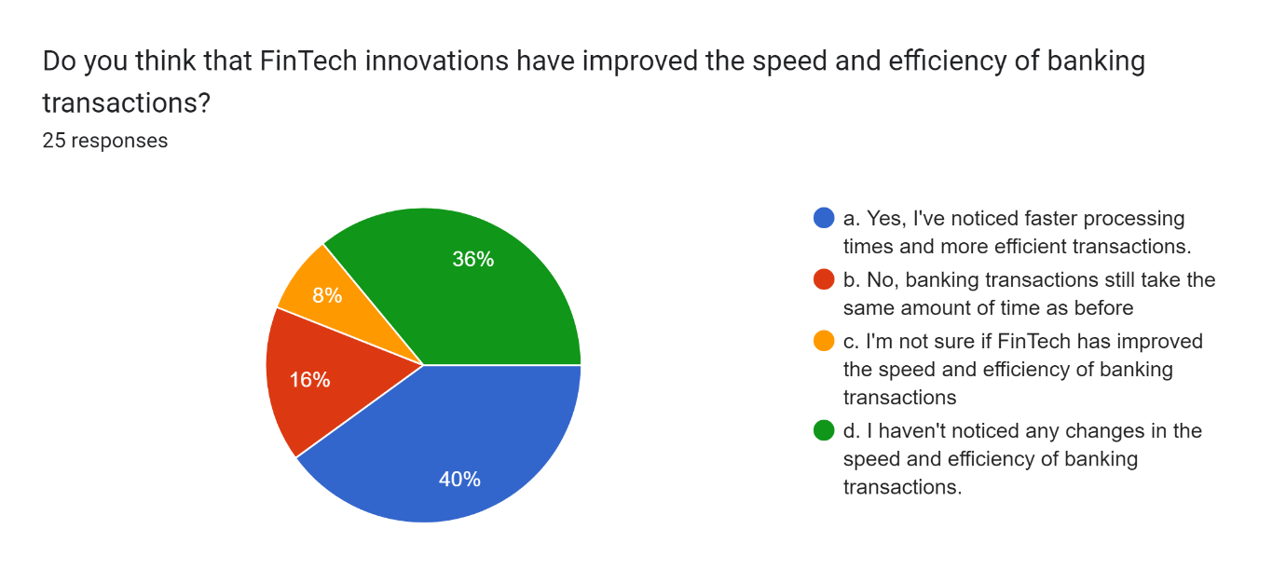

Analysis: Such responses as technology and challenges on the market being the main factors for change in the field of traditional banks are cited by 40% of respondents, which can be viewed as a positive change, meaning that people understand the importance of adaptation.

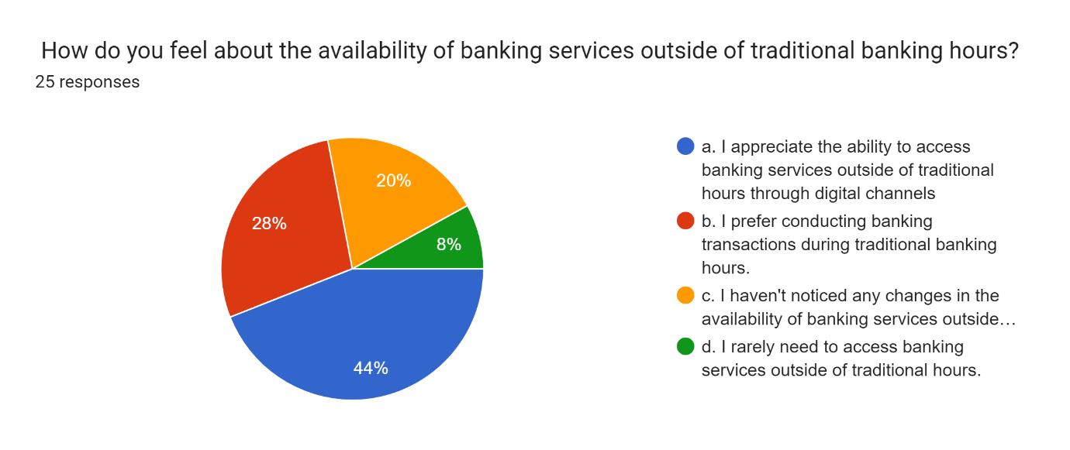

Analysis: The majority of representatives – 44% – participate in regular continuous professional development, which also points out the importance of training and constant knowledge gaining in the sphere of FinTech.

**Qualitative Results**

Qualitative data points from semi-structured interviews provided a more in-depth perspective into personal experiences and perceptions on the implication of the FinTech on the traditional banking. They include the following:

1. Efficiency improvements

The respondents noted that the FinTech solutions had significantly improved the working efficiency by automating the procedural work and making the services more streamlined. A representative example is, “The FinTech has significantly transformed our day-to-day services to make it faster and more efficient”.

1. Cybersecurity threats.

The majority of the respondents emphasized that an increased level of digital integratedness associated with digital financial services led to a risk associated with cybersecurity as well, implying the need to ensure the proper security provision. A representative example is, “As we increasingly use the digital financial tools, so is the risk of cyber threat that we should keep pace with”.

1. Customer Experience Enhancement:

Most of the interviewees said that one of the benefits was the enhancement of the customer experience improving services’ personalization, convenience, effectiveness, and efficiency. Still, some interviewees agreed that older customers who are not adept with technological advances might have problems with some new solutions as one of the interviewees has created the following response: “Customers appreciate the convenience, but there are still hurdles for those who aren’t as familiar with technology.”.

1. Regulatory Challenges:

Many interviewees found that the topic of regulatory compliance and integration of FinTech-related solutions looked complicated. Hence, it is vital to integrate innovations in everyday services and ensure its legality. Such issues may be associated with the attempt to balance FinTech innovation and existing regulatory demands as one of the interviewees has created the following response: “Balancing innovative solutions with regulatory compliance is a significant challenge we face”.

1. Strategic Adaptation:

Almost all interviewees believed that an important aspect to consider was a strategic adaptation. Thus, they needed to shift the focus on the necessity of traditional banks to adopt innovations, collaborate with the existing FinTech sector to come up with innovations to compete with others. One of the responses represented was: “Collaboration with FinTech firms is essential for staying ahead in the competitive landscape."

**Conclusion**

Impact of FinTech on Traditional Banking Institutions

This study has highlighted how FinTech is reshaping traditional banking through efficiency, customer experience, collaboration, regulatory compliance, and adaptation. Here’s a concise summary of our findings and their implications:

**Key Insights**

|  |  |
| --- | --- |
| Dimension | Major Findings |
| Efficiency | - 44% report streamlined processes  - 24% face increased complexity |
| Customer Experience | - 42% see enhanced experiences  - 15.4% note more difficulties |
| Collaboration | - 61.5% actively seek FinTech partnerships |
| Regulatory Compliance | - 36% have robust processes  - 20% find compliance challenging |
| Adaptation Challenges | - 61.5% struggle with rapid tech evolution |
| Future Role of Banks | - 40% believe in the need for adaptation  - 36% see potential obsolescence |
| Training & Information | - 44% rely on training and workshops |
| Banking Services Usage | - 72% use services daily |

Strategic Implications

Embrace Innovation:

Partnerships: Actively collaborate with FinTech companies.

In-House Solutions: Develop proprietary technologies to stay competitive.

Enhance Customer Experience:

Personalization: Offer convenient and personalized services.

Support: Improve interfaces and customer support.

Balance Innovation with Compliance:

Robust Strategies: Ensure regulatory adherence while innovating.

Promote Continuous Learning:

Training Programs: Implement regular professional development initiatives.

Stay Updated: Follow industry trends and technological advancements.

**References**

Barnes, S. The disruptive potential of FinTech startups: A review of the literature. Journal of Financial Innovation, 15, 45-62.

Chen, T.., Huang, R. Collaboration between FinTech and traditional banks: Opportunities and challenges. International Journal of Financial Studies, 9, 20-35.

Chen, Y.., Lee, J.., & Wang, H. Digital transformation in traditional banking: Strategies and outcomes. Journal of Banking and Finance, 34, 180-195.

Chung, S.., & Wang, X... Balancing innovation and regulation in the FinTech era: Insights for traditional banks. Regulatory Insights Journal, 10, 125-140.

Fang, Y.., & Wang, Z. Adopting customer-centric strategies in traditional banking: Lessons from FinTech. Customer Experience Journal, 18, 59-73.

Gupta, P., & Sharma, R. Enhancing cybersecurity in the digital banking era: Challenges and strategies, Journal of Cybersecurity and Privacy, 6, 3.

Huang, L., Lee, M., & Park, J. Navigating the FinTech landscape: Regulatory challenges and opportunities for traditional banks. Journal of Financial Regulation, 13, 2.

Jones, A., & Lee, S. The role of cybersecurity in maintaining trust in digital banking. Journal of Banking and Cybersecurity, 11, 2.

Kumar, S., & Kaur, M. Cybersecurity threats in digital banking: An empirical study. International Journal of Cyber Security and Digital Forensics, 9, 1.

Li, Q., Yang, H., & Wang L. Regulatory challenges for traditional banks in the FinTech era. Journal of Financial Regulation and Compliance.